CS232 Operating Systems Lab 1

Due: Thursday 12/1/2023

Part 1

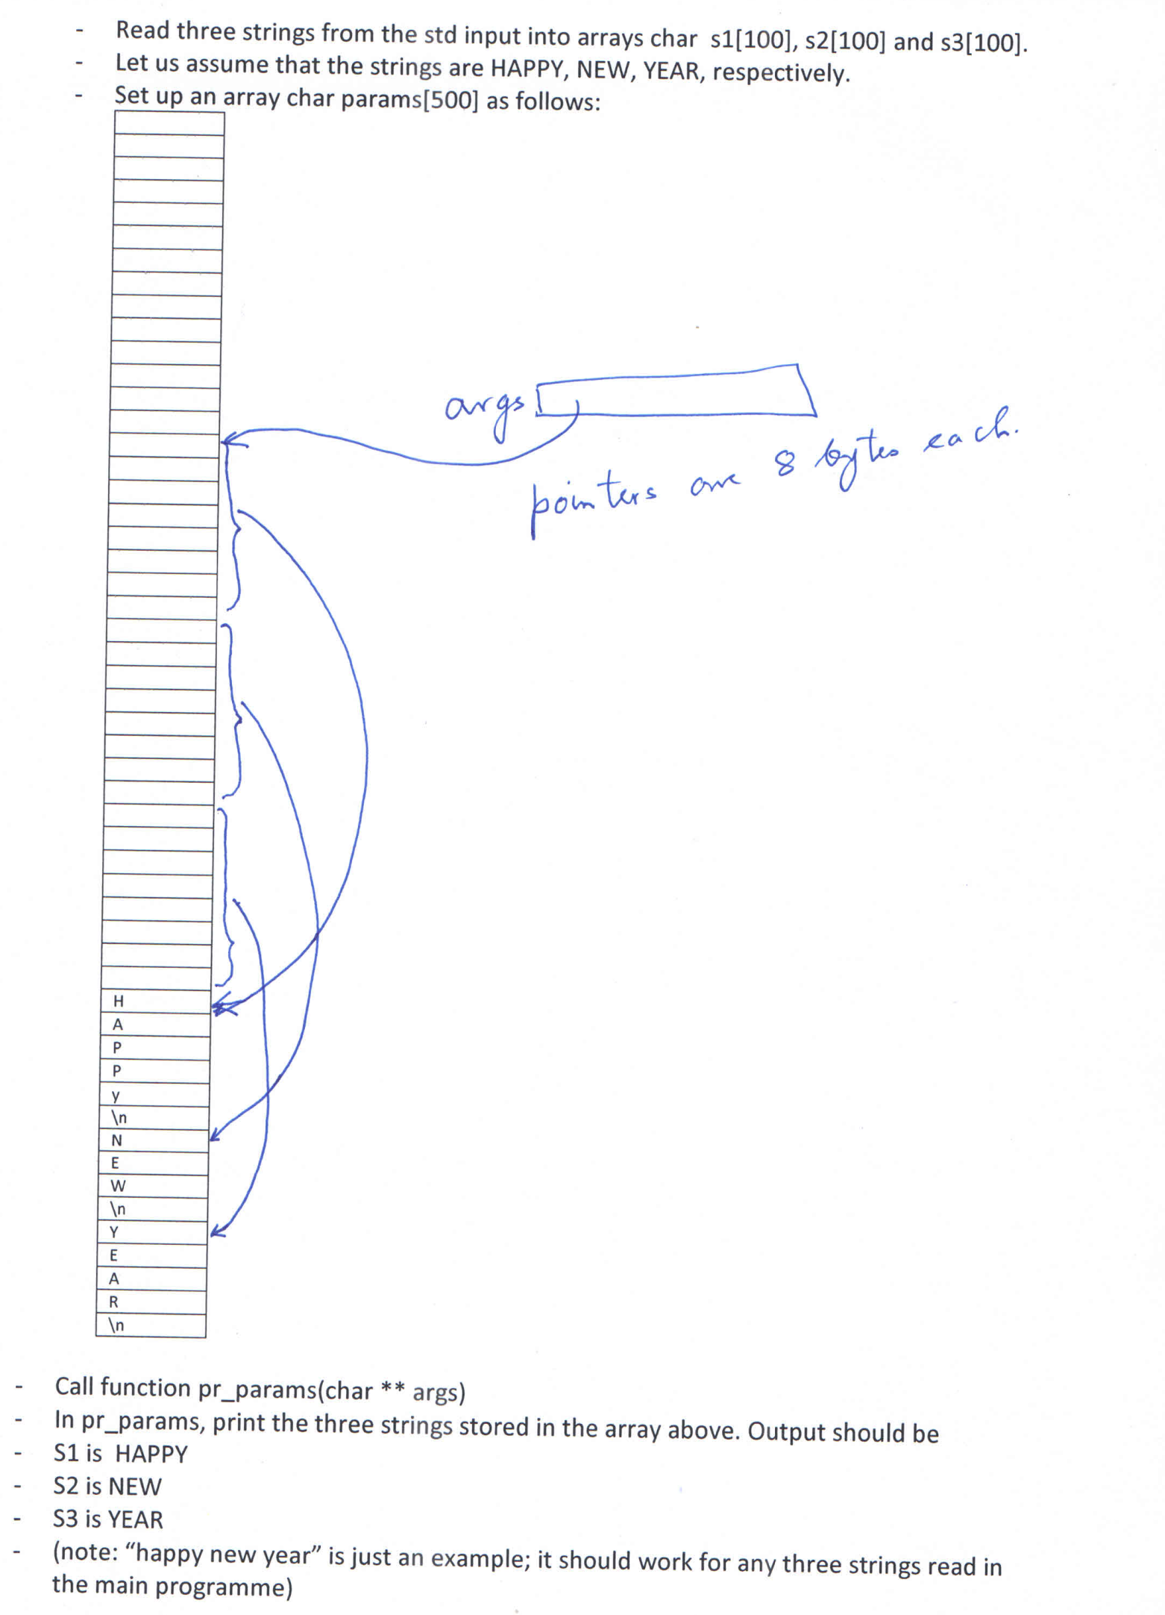

Part 2

Extend the above program to read a value n, and then to read n strings. The rest of the process has to be done on the n strings. The function pr_params will now have two arguments:

Pr_param(int nargs, char ** args)